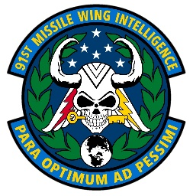OPEN-SOURCE INTEL (OSINT) RESOURCES



AFMC A2: World Threat Brief CAO: 10 Jun 2025 <https://usaf.dps.mil/sites/22244/SitePages/Command-Intel-Threat-Brief.aspx>



China Aerospace Studies Institute: CASI supports the Secretary of the Air Force, Joint Chiefs of Staff, and other senior leaders of the Air and Space Forces. CASI provides expert research and analysis supporting decision and policy makers in the Department of Defense and across the U.S. government.

<https://www.airuniversity.af.edu/CASI/>

Research and Development Corporation (RAND): RAND is a nonprofit, nonpartisan research organization that provides leaders with the information they need to make evidence-based decisions.



<https://www.rand.org/>

Institute for the Study of War: The Institute for the Study of War (ISW) is a non-partisan, non-profit, public policy research organization. ISW advances an informed understanding of military affairs through reliable research, trusted analysis, and innovative education.

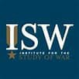

<https://www.understandingwar.org/>

Stockholm International Peace Research Institute: SIPRI is an independent international institute dedicated to research into conflict, armaments, arms control and disarmament. Established in 1966, SIPRI provides data, analysis and recommendations, based on open sources, to policymakers, researchers, media and the interested public.

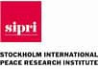

<https://www.sipri.org/>

Strategic Forecasting Inc. (VIA AF PORTAL): Strategic Forecasting Inc., commonly known as Stratfor, is an American strategic intelligence publishing company founded in 1996. Stratfor's business model is to provide individual and enterprise subscriptions to Stratfor Worldview, its online publication, and to perform intelligence gathering for corporate clients.



<https://worldview.stratfor.com/>

Defense Intelligence Agency Military Power Publications: an intelligence agency and combat support agency of the United States Department of Defense, specializing in defense and military intelligence. <https://www.dia.mil/Military-Power-Publications/>



Perun: An Australian covering the military industrial complex and national military investment strategy. [https://www.youtube.com/@PerunAU](https://www.youtube.com/%40PerunAU)

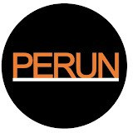

Task & Purpose: Task & Purpose was founded in 2014 with a mission to inform, engage, entertain, and stand up for active-duty military members, veterans, and their families. The site quickly became one of the most trusted news and investigative journalism sources for the military, with its journalists reporting everywhere from the Pentagon to The White House and beyond.



[https://www.youtube.com/@Taskandpurpose](https://www.youtube.com/%40Taskandpurpose)

The Center for Strategic and International Studies (CSIS): is a bipartisan, nonprofit policy research organization dedicated to advancing practical ideas to address the world’s greatest challenges.

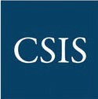

<https://www.csis.org/>



FRONTLINE examines the rise of Xi Jinping, his vision for China and the global implications. Correspondent Martin Smith traces the defining moments for President Xi, how he’s exercising power and his impact on China, and relations with the U.S. and the world. <https://www.pbs.org/wgbh/frontline/documentary/china-the-u-s-the-rise-of-xi-jinping/>